Savitribai Phule Pune University

**MASTER OF COMPUTER APPLICATION**



**Jayawant Shikshan Prasarak Mandal’s**

**Jayawantrao Sawant College of Engineering, Hadapsar**

A

**Project Report**

On

“Bonafide Certificate Generator”

**SUBMITTED BY-**

**Pranav Chandrakishor Pathare**

**(Seat No:3875)**

UNDER THE GUIDANCE OF

**Prof. Anil Gaikwad**

**MCA Department**

Semester -II

For Academic Year 2022-23

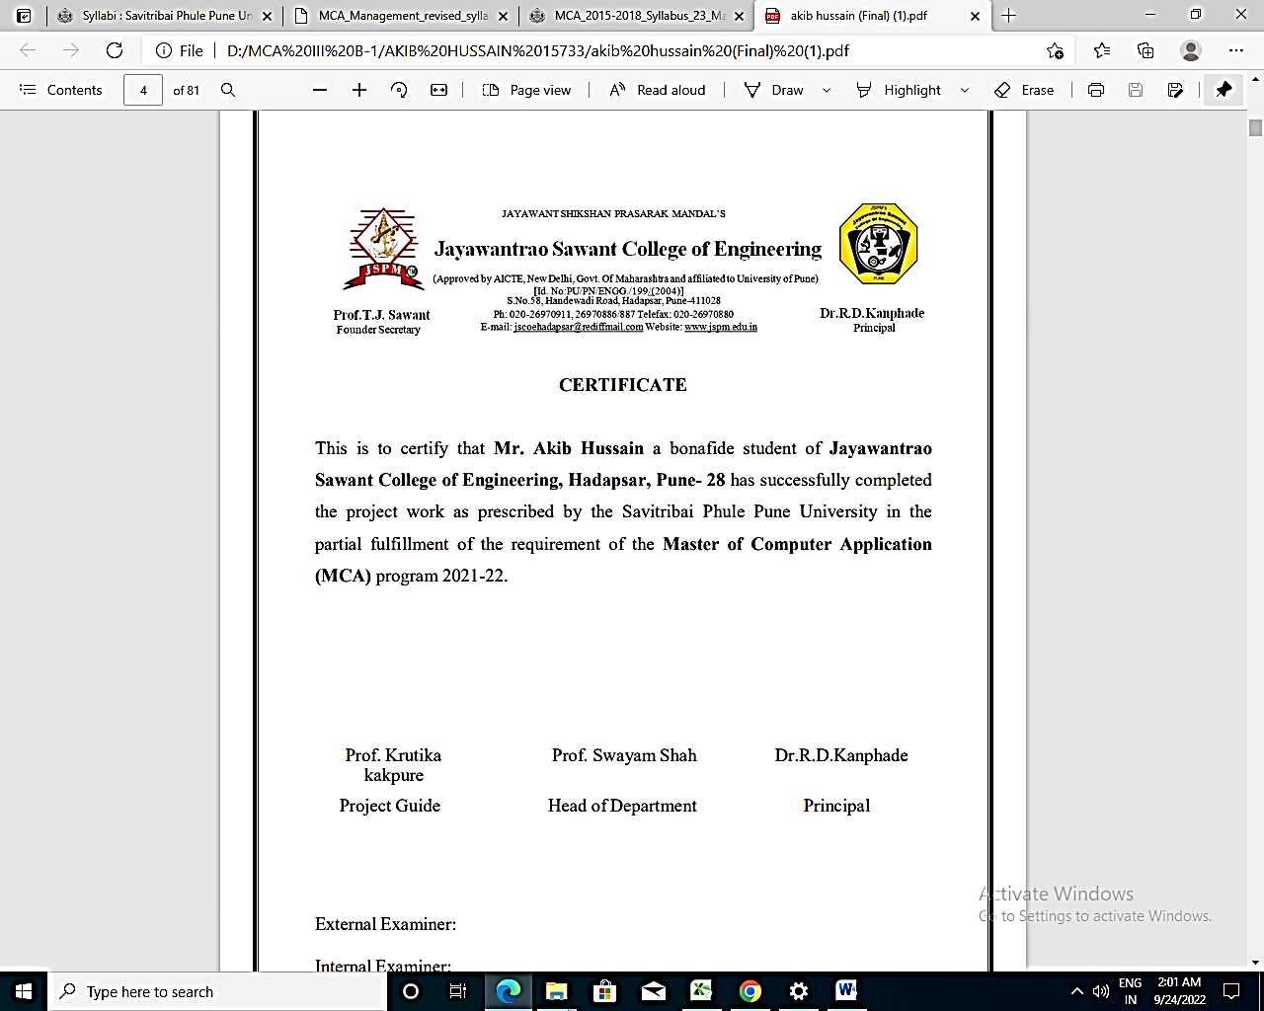**------------------------------------------------------------------------------------------------------------------**

**CERTIFICATE**

This is to certify that **Mr. Pranav Chandrakishor Pathare i**s a bonafide student of Jayawantrao Sawant College of Engineering, Hadapsar, Pune-28, has successfully completed the Mini Project work in the Partial Fulfillment of Master of Computer Application (MCA) Program as per guidelines provided by the Savitribai Phule Pune University for Academic Year 2022-23

|  |  |  |
| --- | --- | --- |
| Prof. Anil Gaikwad | Prof. Swayam Shah | Dr. R. D. Kanphade |
| Project Guide | HOD | Principal |
| External Examiner: |  |  |
| Internal Examiner: |  |  |
| Date: / /2023 |  |  |
| Place: Pune |  |  |

**Declaration**

To,

The Principal,

Jayawantrao Sawant college of Engineering,

Hadapsar, Pune-28

Respected Sir,

I, Mr. **Pranav Chandrakishor Pathare** hereby declare that the Mini Project entitled “**Bonafide Certificate Generator**” has been developed and submitted under the guidance of **Prof. Anil Gaikwad** is my original work.

The Project work presented here is my own work and has not been duplicated from any other sources.

|  |  |
| --- | --- |
| Date: / /2023 | Yours Sincerely |
| Place: Pune | Purushottam Bharat Gutthe |

**Acknowledgement**

I would take this opportunity to thank Dr. R. D. Knaphade Sir, Principal of JSCOE for their extended support to me throughout the course.

I would like to thank Prof. Swayam shah sir, HOD, MCA Department for scholarly disposition, timely guidance, support and cooperation.

I would like to thank Prof. Anil Gaikwad for his/her kind guidance, keen interest, continuous encouragement and inspiration throughout the project work.

Finally, I am grateful to all the staff members of JSCOE for their cooperation and support.

I also thankful to get constant encouragement, support and guidance from all teaching and non-teaching staff for their support which helped us in successfully completion of our project work.

**Mr.** **Purushottam Bharat Gutthe**

Exam Seat No: - 3875

**Index**

|  |  |  |
| --- | --- | --- |
| **Sr. No.** | **Title** | **Page No.** |
| **1)** | **INTRODUCTION**  1.1) Literature Survay  1.2) Problem Defination  1.3) Proposed Methodology Of solving Identified Problem  1.4) Resources & Consumables Required  1.5) Purpose of the Project  1.6) Existing System  1.7) Proposed System  1.8) Hardware/Software Required  1.9) Future Scope | **1** |
| **2)** | **System Analysis**  2.1) Purpose Of the Project  2.2) Existing System  2.3) Proposed System  2.4) Implimentation  2.5) Future Scope | **8** |
| **3)** | **Feasibility Report**  3.1) Technical Feasibility  3.2) Operational Feasibility | **9** |
| **4)** | **Technology**  4.1) Python  4.2) Django  4.3)HTML  4.4) Sqlite | **10** |
| **5)** | **System Design**  5.1) Algorithm  5.2) Flowchart  5.3) Use Case Diagram  5.4) Component Diagram  5.5) ER Diagram  5.6) Class Diagram | **14** |

|  |  |  |
| --- | --- | --- |
| **Sr. No.** | **Title** | **Page No.** |
| **6)** | **System Design**  6.1) Levels of Testing  6.1.1) Functionality Testing  6.1.2) Structural testing  6.2) Testing process  6.2.1) Test plan  6.2.2) Test case specification  6.2.3) Test case execution and analysis  6.2.4) Unit testing  6.2.5) Integration testing | **20** |
| **7)** | **Screenshots** | **23** |
| **8)** | **Conclusion** | **26** |
| **9)** | **Bibliography** | **27** |